INTEGRATION DOCUMENT

Audio format

Document history:

S. No | Ver.No. | Author | Section(s) Affected | Change(s) made | Approved Date | Approved by
1 | 1.0 | Nithishkumar T | All | Initial
2 | 1.1 | Nithishkumar T | 2.3  5 | MIPS calculation and Block diagram

Table of Contents

1 INTRODUCTION 2
1.1 PURPOSE 2
1.2 SCOPE 3
2 ALGORITHM OVERVIEW 3
2.1 SPECIFICATIONS 4
2.2 FEATURES 4
2.3 BASIC BLOCK DIAGRAM 5
3 IMPLEMENTATION OVERVIEW 6
3.1 OVERVIEW OF ALGORITHM IMPLEMENTATION 6
3.2 SPECFICATIONS IMPLEMENTED 7
3.3 BUFFER/DATA FLOW DIAGRAM 7
4 SOFTWARE INTERFACE PROTOCOL 7
4.1 INPUT PARAMETERS 7
4.2 OUTPUT PARAMETERS 8
4.3 SPECIAL HANDLING 9
5 MIPS & MEMORY DETAILS 9
Appendix A 13

INTRODUCTION

PURPOSE
The purpose of this document is to provide a comprehensive description of the audio format conversion algorithm implemented in the project. The algorithm is designed to facilitate the conversion of audio data between different formats, specifically Block Format and Interleaved Format. This conversion can be applied to both Block Files and Interleaved Files, making the solution flexible for a variety of audio processing systems.
The main objective of the project is to allow seamless conversion of multi-channel audio data, enabling compatibility between different audio processing systems that may require different data storage formats. By handling both Block and Interleaved Formats, the algorithm supports various use cases such as digital signal processing (DSP), real-time audio applications, and embedded systems where high performance and memory efficiency are essential.

SCOPE
This project addresses the conversion of audio data stored in different formats, focusing on

- Block Format
Audio data is stored in separate blocks for each channel. Each block corresponds to a time frame for one channel, allowing easy access to individual channel data.

- Interleaved Format
Audio data is stored such that the samples from different channels are interspersed. For example, for 8 channels, the samples would be stored in a sequence like [ch1_sample_1, ch2_sample_1, ch3_sample_1, ..., ch8_sample_1, ch1_sample_2, ch2_sample_2, ...].

The scope includes:
- Converting between formats
The project supports conversion from Block Format to Block Format, Block Format to Interleaved Format, and vice versa.

- Handling file types
The conversion functions can handle different input file types and adapt accordingly.

- Data output
The converted audio data is written to an output file in hexadecimal format, providing a simple and human-readable output for further analysis or use.

ALGORITHM OVERVIEW

The Audio Format Conversion project involves transforming audio data between different formats—specifically Block Format and Interleaved Format—and writing the converted data to an output file. The conversion logic is encapsulated in a set of algorithms designed to handle multi-channel audio data efficiently. This section provides an overview of the algorithm specifications, features, and a basic block diagram representing the high-level flow of the system.

SPECIFICATIONS

Reference Code Revision | Custom implementation
Target Processor | ADSP2593
Channel Configuration | 8 channels (configurable through NO_OF_CHANNELS)
Input Format | Block Format or Interleaved Format
Output Format | Block Format or Interleaved Format
Block size | 20 samples per channel (defined by SIZE = 20)
Sample Rate | 48 kHz (default, can be adapted based on input data)
Bit Rate | 12.288 Mbps (for 8 channels, 32-bit, 48 kHz sample rate)
Conversion Types Supported | Block to Block, Block to Interleaved, Interleaved to Block, Interleaved to Interleaved
File Types Supported | Block File, Interleaved File
Data Format for Output | Hexadecimal (in a text format for each sample, one per line)

FEATURES
- Multi-Channel Support
  - Supports up to 8 channels of audio data (configurable via NO_OF_CHANNELS). It can be modified based on the needs.
  - The algorithm can manage different numbers of output channels (via OUTPUT_CHANNELS). It can be modified based on the needs.
- File Handling
  - Supports input files in both Block and Interleaved formats.
  - Allows output in the same formats, with the option to handle different file types using flags.
- Optimized Performance
  - Utilizes compiler-specific pragmas like #pragma vector_for and #pragma no_alias to enable parallelization and optimize loop performance on supported hardware.
  - Memory handling is efficient, with the use of a static array destination[] and minimal dynamic memory allocation.
- Conversion Logic
  - Provides flexibility to handle conversions between Block and Interleaved formats.
  - Includes checks for invalid conversion types or file types, ensuring robustness.
- Scalability
  - The algorithm can be adapted to handle different numbers of channels by modifying SIZE and NO_OF_CHANNELS.
- Output Generation
  - Converted audio data is written to an output file in a human-readable hexadecimal format, which is useful for debugging or further processing.

BASIC BLOCK DIAGRAM
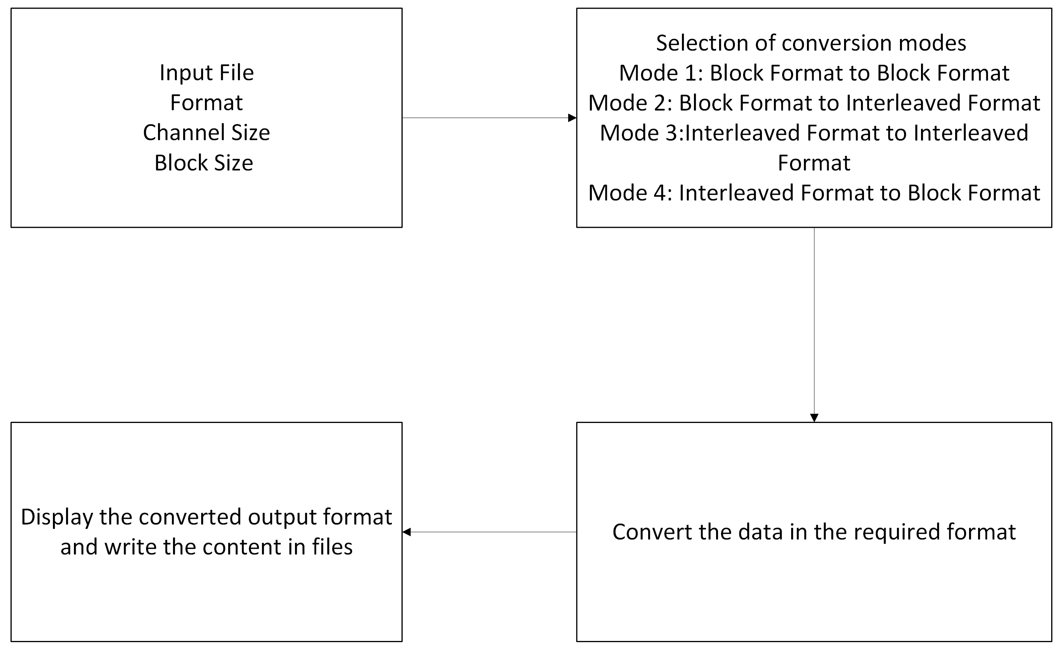

The above block diagram outlines a process for converting data between two different formats: Block Format and Interleaved Format. It specifies four conversion modes and describes the required data input and output procedures.
- Channel Size & Block Size
The input data must first be organized according to its channel size and block size. These parameters are crucial in defining how the data is structured and managed during the conversion process.
- Selection of Conversion Modes
The system offers four conversion modes, each designed to convert between different formats:
Mode 1: Block Format to Block Format – Converts data within the same format but may involve adjustments like reorganization or optimization.
Mode 2: Block Format to Interleaved Format – Converts data from Block Format (where each channel's data is grouped together) into Interleaved Format (where data from all channels is interwoven).
Mode 3: Interleaved Format to Interleaved Format – Converts data between two different interleaved formats, possibly with different interleaving patterns or sizes.
Mode 4: Interleaved Format to Block Format – Converts data from Interleaved Format (where data from different channels is mixed together) back into Block Format (where data from each channel is grouped separately).
- Conversion of Data
The system processes the input data according to the selected conversion mode. It rearranges or restructures the data to match the desired output format.
- Output and File Writing
After conversion, the system displays the converted data in the required format. The processed data is then written to files for storage or further use.

IMPLEMENTATION OVERVIEW

OVERVIEW OF ALGORITHM IMPLEMENTATION

The algorithm reads audio data from a specified input file into an array. It then processes the data based on the specified conversion and file_type parameters. The algorithm uses nested loops to rearrange the data according to the selected format conversion. The result is stored in the destination array, and the output is written to a file.

SPECFICATIONS IMPLEMENTED
The implemented specifications are
- File Reading
Audio data is read from a file (MCPCM_48K_Sine_input.dat). It can be modified based on the needs.
- Data Processing
The data is processed based on the conversion type and file type
    - Block Format to Block Format
    - Block Format to Interleaved Format
    - Interleaved Format to Interleaved Format
    - Interleaved Format to Block Format
- Handling of Output Channels
If the number of output channels exceeds the number of input channels, the algorithm will repeat the data to fill the extra channels.
- File Writing
The processed data is written to an output file (output_file.dat).

BUFFER/DATA FLOW DIAGRAM

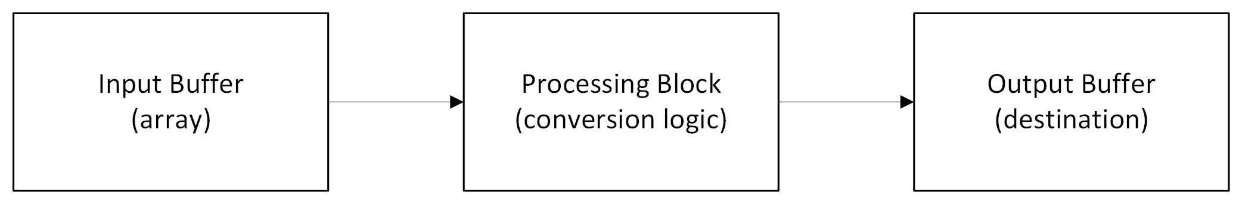
The input buffer reads audio data into an array, which is processed according to the conversion logic. The output is stored in the destination buffer before being written to a file.

SOFTWARE INTERFACE PROTOCOL

The Software Interface Protocol section describes the interaction between the software modules and the inputs/outputs for the Audio Format Conversion algorithm. This section provides an overview of the input and output parameters, a pseudocode representation of the algorithm, how the system communicates with the host (e.g., file handling and error management), and any special handling of edge cases or exceptional conditions.

INPUT PARAMETERS

S.No | Parameter Name | Bit Definition | Description
1 | input_file | String (array of characters) of size 128 or more (char[]) | The name of the input file (e.g., MCPCM_48K_Sine_input.dat) containing the audio data
2 | file_type | 32-bit integer (int32_t) | Defines the format of the input file: 1 for Block File, 2 for Interleaved File
3 | array[] | Each element is a 32-bit signed integer (int32_t) | Array holding the input audio data for all channels, represented in hexadecimal format
4 | SIZE | 32-bit integer (int32_t) | The number of audio samples per block per channel (e.g., 20 samples)
5 | NO_OF_CHANNELS | 32-bit integer (int32_t) | The number of input audio channels. For example, 8 channels
6 | OUTPUT_CHANNELS | 32-bit integer (int32_t) | The number of output channels required. If greater than NO_OF_CHANNELS, channels are replicated
7 | conversion | 32-bit integer (int32_t) | Specifies the type of conversion to perform: 1 (Block to Block), 2 (Block to Interleaved), 3 (Interleaved to Interleaved), or 4 (Interleaved to Block)
8 | output_file | String (array of characters) of size 128 or more (char[]) | The name of the output file (e.g., output_file.dat) where the converted audio data will be written

OUTPUT PARAMETERS

S.No | Parameter Name | Bit Definition | Description
1 | destination[] | Each element is a 32-bit signed integer (int32_t) | Array that holds the converted audio data (in hexadecimal format) after the specified conversion process is applied
2 | output_file | String (array of characters) of size 128 or more (char[]) | The name of the output file (e.g., output_file.dat) where the converted audio data will be written in hexadecimal format
3 | status_message | String (array of characters) of size 128 or more (char[]) | Holds status or error messages related to the conversion process (e.g., "Conversion Complete!" or error messages like "Error opening file")

SPECIAL HANDLING

- Output Channel Expansion
If the output channels exceed the number of input channels, the algorithm repeats the data to fill the extra channels.
- File I/O Errors
The algorithm checks for file opening errors and ensures that the input file is properly read and the output file is correctly written.

MIPS & MEMORY DETAILS

MEMORY

The destination buffer is mapped in the L3 memory. This destination buffer is configured as static buffer and placed in the L3 memory location.

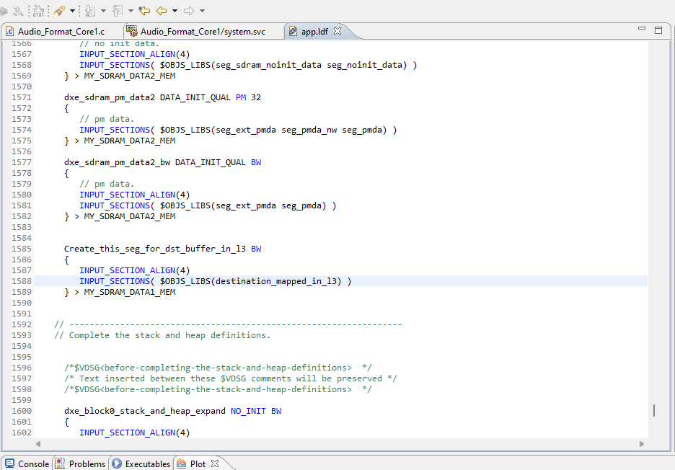

MIPS

MIPS Calculation
To evaluate the performance of the function, the MIPS (Million Instructions Per Second) metric was calculated using the following formula:

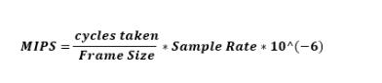

Stream Used | Sampling Rate | Cycles Taken | Frame Size | MIPS
MCPCM_48K_Sine_input.dat | 48kHz | 2849 | 20 | 0.006837
sample.dat | 48kHz | 2249 | 20 | 0.005397
sample.dat | 48kHz | 2721 | 20 | 0.006530
sample_block.dat | 48kHz | 2849 | 20 | 0.006837
sample_block.dat | 48kHz | 2721 | 20 | 0.006530

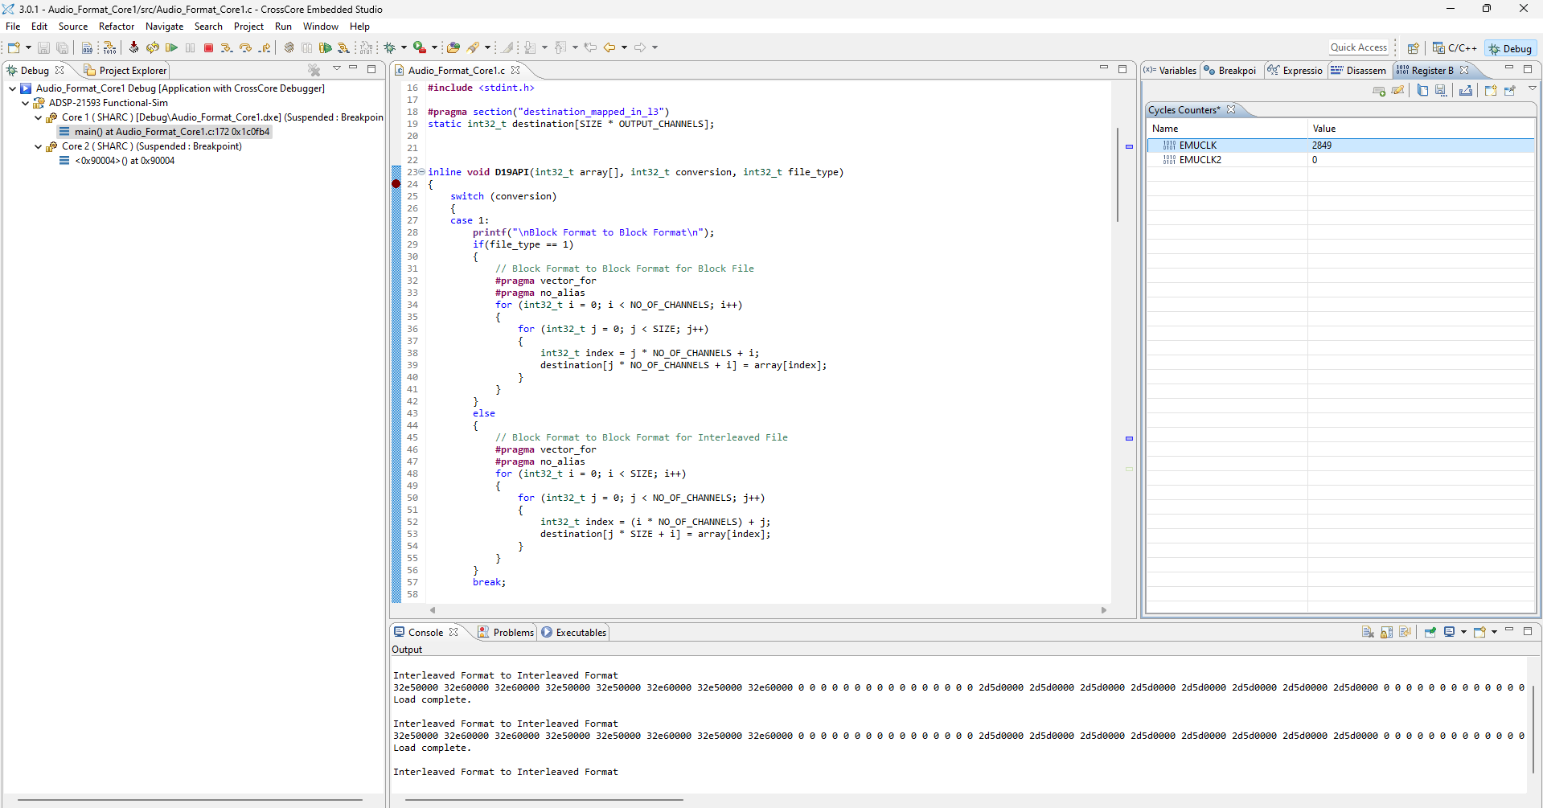
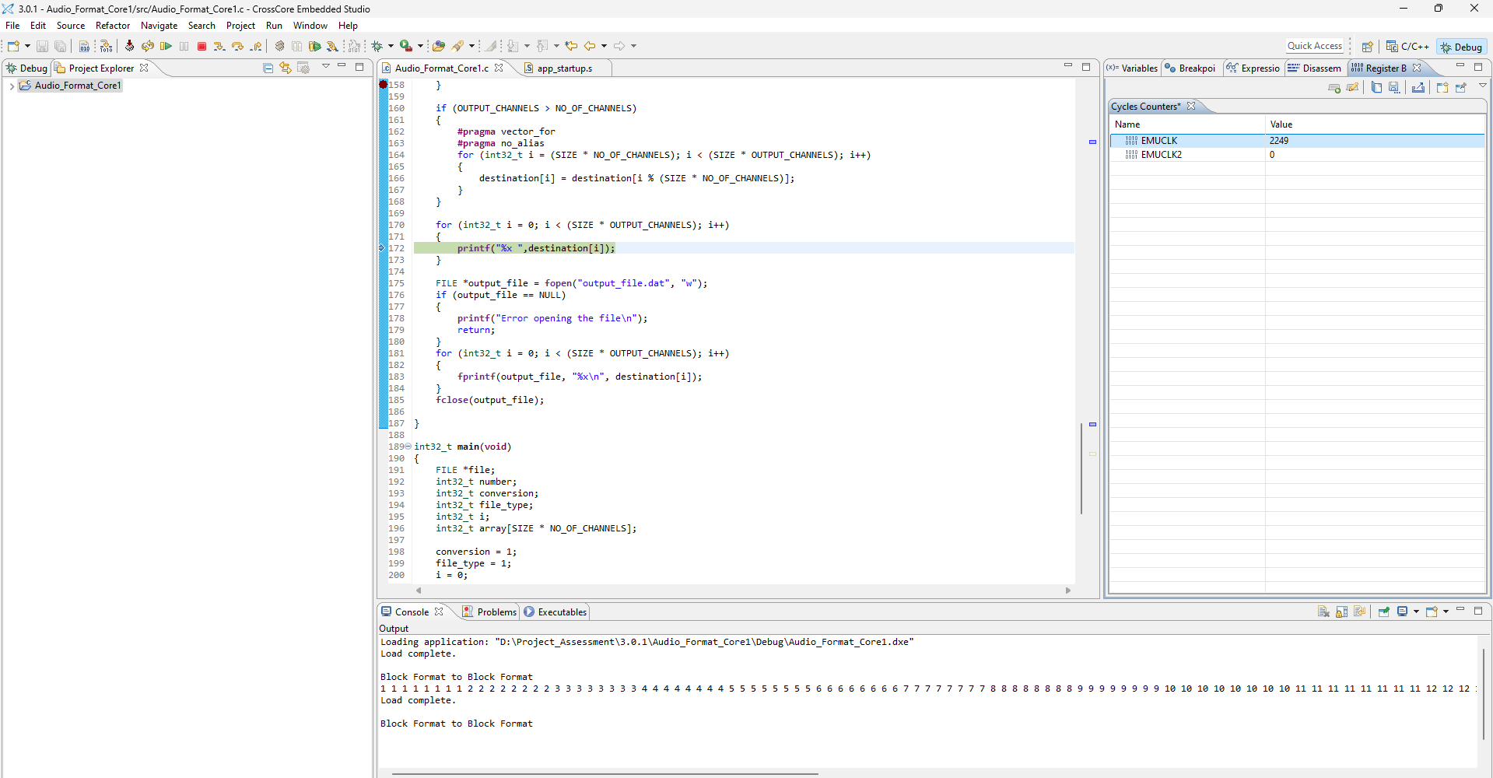
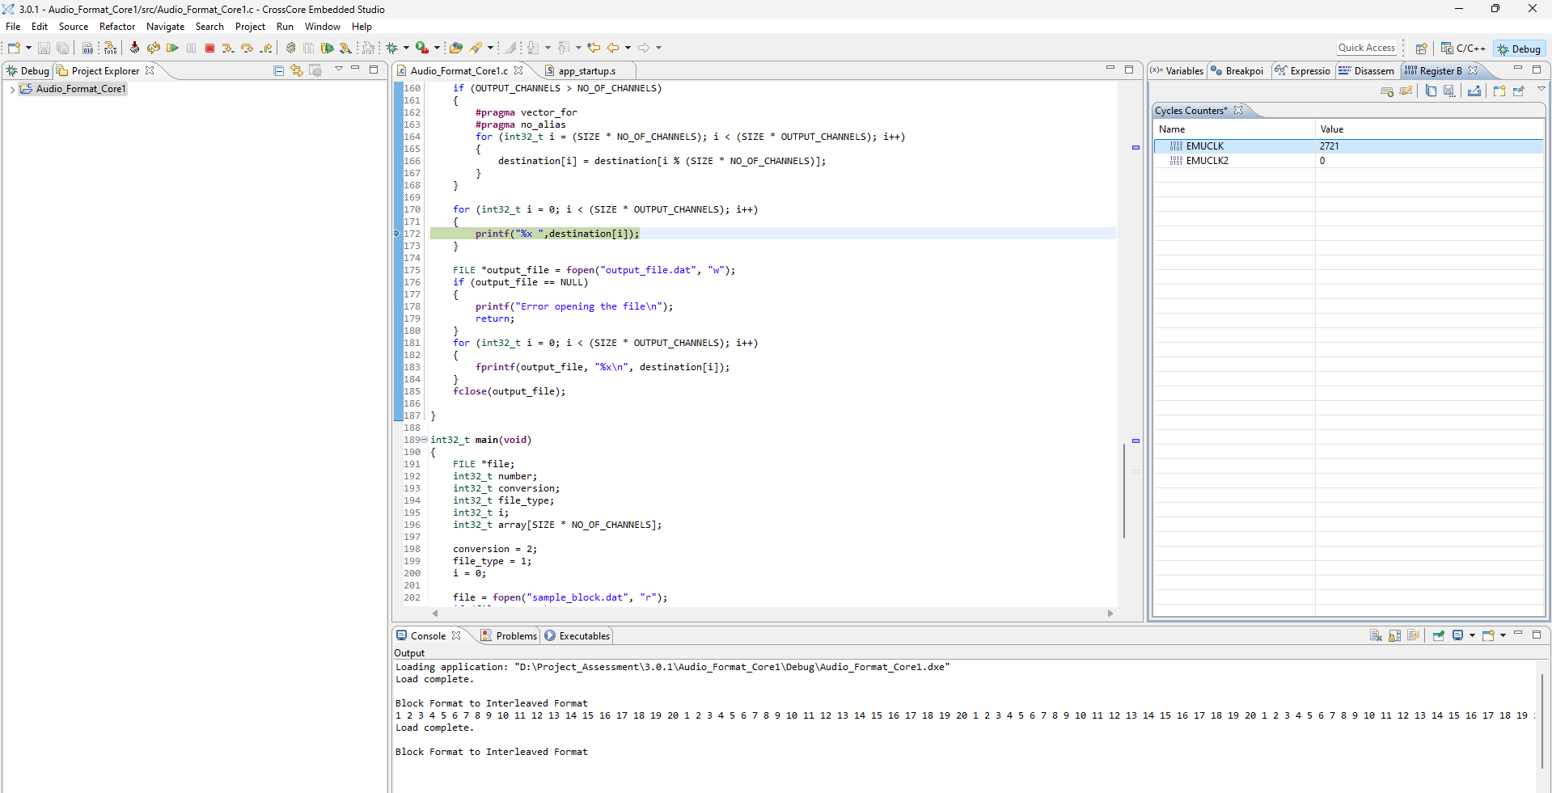
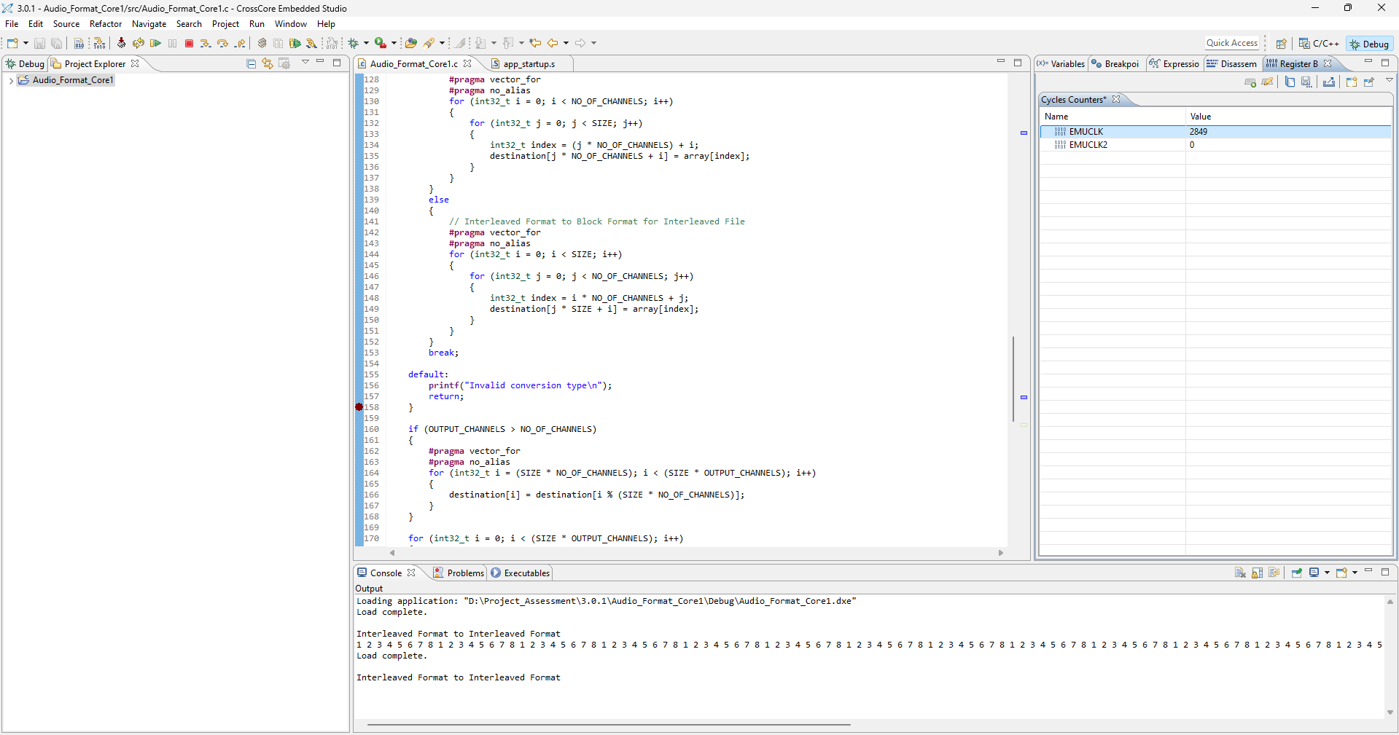
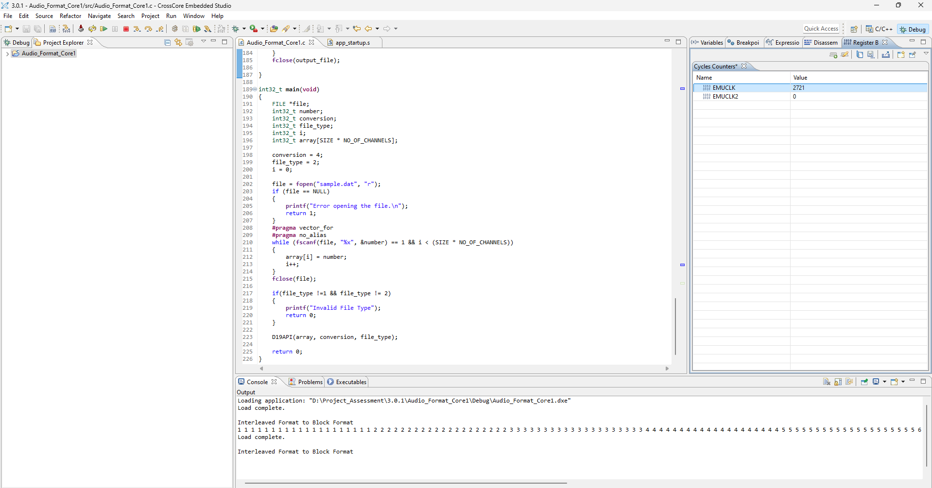

[Please mention the tips for optimized integration. The tradeoff for MIPS and Memory of the algorithm/project shall be mentioned here like if certain buffers should not be placed in Block 0 or any other similar optimization tips.]

